**SynDx Prototype: Enhanced Digital Tool for Syndromic STI Diagnosis Harmonizing WHO Guideline and AI-Based Reasoning**

**Abstract**

Background: Sexually transmitted infections (STIs) remain a major public health challenge in low- and middle-income countries, where WHO syndromic management algorithms continue to guide care. To date, no digital tools and published studies to laverage WHO syndromic algorithms with artificial intelligence. In contrast, we developed Syndx dashboard as a prototype AI-assisted system that integrates WHO guidelines with AI-based reasoning to enhance transparency, usability, and training value in STI care.

**Methods:** The dashboard was implemented using Python 3.13.5 within a conda-managed environment and built on the Streamlit framework. Version control was maintained using Git with repositories hosted on GitHub. Core libraries included pandas, numpy, scikit-learn, matplotlib, seaborn, plotly, python-dotenv, and the OpenAI Python client. The system architecture consisted of (i) a rule-based module encoding WHO syndromic algorithms, (ii) an AI module integrated via the OpenAI API, and (iii) a user interface with seven functional components. Deployment was performed on Streamlit Cloud, enabling browser-based access without local installation.

**Results:** SynDx dashboard integrated seven functional modules-including Diagnosis, Case History, Analytics, and Clinical Guidelines-while harmonizing outputs with AI reasoning to add differential diagnoses, triage alerts, and patient SMS communication. This combination preserved transparency with WHO guidelines while providing clear added value through AI augmentation. In testing with 25 synthetic cases (10 females, 15 males; ages 16-51; HIV-negative n=10, HIV-positive n=8, unknown n=7), Syndx reproduced all WHO syndromic categories with 100% concordance (Cohen’s Kappa=1.0). While WHO algorithms did not account for behavioral risk factors, the AI module incorporated them to generate individualized reasoning, thereby preserving transparency with WHO guidelines while providing added value through AI augmentation.

**Conclusion:** The Syndx prototype demonstrates the feasibility of combining WHO-standard syndromic management with AI-enhanced reasoning in a transparent dashboard environment. By integrating triage, guideline-based recommendations, AI commentary, and patient SMS delivery, Syndx has potential to strengthen STI care, improve clinical decision-making, and support training of healthcare workers in resource-limited settings. Further validation in real-world clinical environments is warranted.

**Background**

Sexually transmitted infections (STIs) are a group of infectious diseases that are primarily transmitted through sexual contact, including vaginal, anal, and oral intercourse. They are caused by a wide range of pathogens such as bacteria (Neisseria gonorrhoeae, Chlamydia trachomatis, Treponema pallidum), viruses (HIV, HPV, HBV, HSV), and parasites (Trichomonas vaginalis). Beyond sexual transmission, some STIs can also be spread through blood transfusion, sharing of contaminated needles, and from mother to child during pregnancy, delivery, or breastfeeding(1).

Sexually transmitted infections (STIs) remain a significant public health concern worldwide, with an estimated 374 million new infections of curable STIs (chlamydia, gonorrhea, syphilis, and trichomoniasis) occurring annually according to the World Health Organization (WHO). In low- and middle-income countries (LMICs), where diagnostic resources are limited, syndromic management has been the cornerstone of STI control since the 1990s(2). The WHO syndromic management guidelines allow primary health care (PHC) providers to treat patients based on presenting symptoms and signs without requiring laboratory confirmation. This approach has been credited with improving access to care and reducing delays in treatment initiation(3). Despite its wide adoption, syndromic management has notable limitations; the reliance on symptom clusters often leads to both over-treatment and under-treatment, as overlapping clinical features make it difficult to differentiate between pathogens(4,5). A cohort study from Kenya reported agreement between syndromic and aetiological diagnoses was poor, with an overall kappa = 0.09(6).

Recent advances in artificial intelligence (AI), particularly natural language processing (NLP) models such as Generative Pre-trained Transformers (GPT), offer new opportunities to enhance clinical decision support in resource-limited settings. AI can provide probabilistic reasoning, highlight differential diagnoses, and offer contextualized recommendations while aligning with established guidelines. Unlike static rule-based algorithms, AI systems can integrate multiple inputs such as symptom combinations, risk factors, comorbidities, and patient demographics to generate more tailored insights(7–10).

However, there were no tools to date have attempted to harmonize AI reasoning with WHO’s rule-based syndromic management in a clinically safe and transparent way. The lack of integration between guideline-based standards and adaptive AI reasoning leaves a critical gap in supporting frontline providers in PHC facilities. To address this gap, we developed SynDx, a prototype AI-enhanced digital dashboard for syndromic STI diagnosis. SynDx integrates WHO 2016 syndromic guidelines with GPT-based reasoning, presenting both rule-based and AI-generated outputs side by side. The tool also provides commentary to highlight areas of agreement, divergence, and potential nuance, while preserving WHO recommendations as the clinical anchor. This approach seeks to improve transparency, clinician confidence, and the usability of syndromic management in real-world PHC settings.

**Methods**

**Study Design**

We conducted a developmental and validation study of *SynDx*, a prototype digital decision support tool for syndromic management of STIs. The tool was constructed as a hybrid system that combined the WHO syndromic management guidelines with an AI-powered reasoning module. The development process involved embedding guideline-based diagnostic pathways into the digital interface and integrating AI-generated interpretive outputs to supplement clinical decision-making.

For validation, we applied the prototype to a series of synthetic patient case scenarios that represented a range of real-world presentations of STI syndromes. The evaluation framework compared concordance between WHO guideline outputs and the AI module outputs, while also assessing the interpretive value added by the AI commentary.

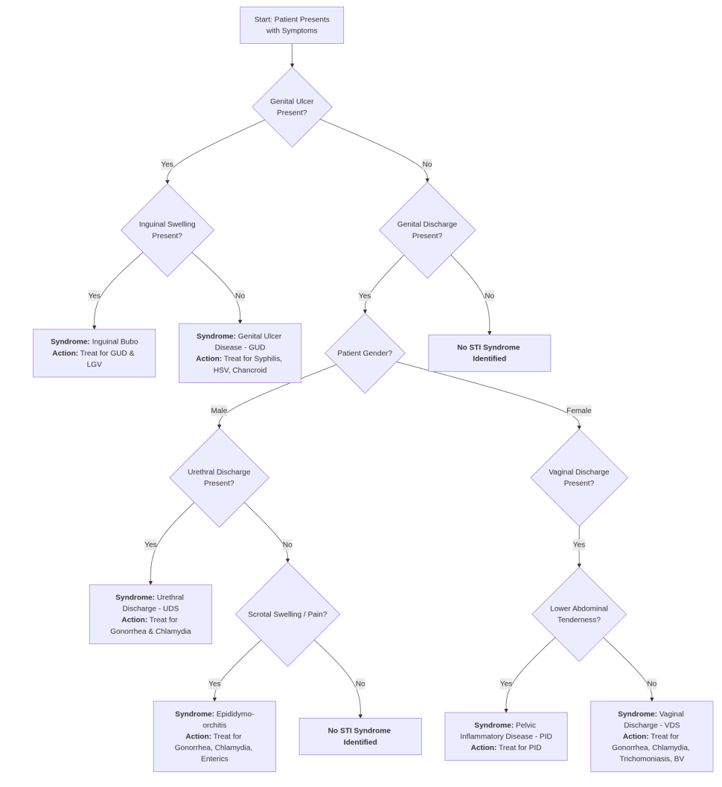

**System Architecture**

The Syndx dashboard was developed on a Linux-based environment (Pop!_OS 22.04) using Python 3.13.5 within a conda-managed environment. To ensure reproducibility and collaborative development, Git was employed for version control and repositories were hosted on GitHub, enabling transparent tracking of code revisions and seamless integration of new features.

The development stack combined a set of widely adopted Python libraries. Streamlit served as the core framework for building the interactive dashboard, while pandas and numpy underpinned data handling and preprocessing. Visualization and reporting were supported by matplotlib, seaborn, and plotly, whereas scikit-learn was incorporated for machine learning utilities to support analytical expansion in later iterations. Secure handling of API keys and environment variables was achieved using python-dotenv, and the OpenAI Python client enabled integration with the GPT-3.5 API for AI-driven diagnostic reasoning.

The architecture was modular, consisting of functional dashboard components designed for clinical usability and research extensibility:

* **About Syndx**- provided an overview of the tool, its scope, and guidance for users.
* **Diagnosis**-the core decision support interface where patient demographics, vital signs, symptoms, risk factors, and free-text notes were entered. Outputs from the WHO syndromic algorithms and the AI module were displayed side by side, with an additional AI commentary column to enhance interpretability.
* **Case History**-maintained a structured archive of patient-level diagnostic records for follow-up and audit.
* **Export**-allowed users to securely download case-level data and diagnostic summaries for integration into external workflows.
* **Analysis Dashboard**-provided visualizations and aggregated statistics on syndromes, probable etiologies, and treatment patterns to support surveillance and research.
* **Clinical Guidelines**-embedded WHO STI syndromic management protocols and national treatment guidelines for quick reference during consultations.
* **Training and Education**-offered interactive modules and resources for capacity building among healthcare workers, reinforcing correct STI management practices.

At the core of the system were two processing modules. The rule-based module encoded WHO syndromic algorithms, mapping symptom clusters to standardized STI syndromes and associated treatment recommendations. In parallel, the AI module processed the same structured inputs through the OpenAI GPT-3.5 API, generating contextual reasoning such as risk assessment, severity highlighting, and follow-up recommendations while remaining restricted to the STI domain.

By combining WHO-standard outputs with AI-augmented reasoning, and embedding them into a dashboard that integrates diagnostic, analytical, educational, and guideline components, the Syndx architecture ensured both clinical transparency and scalability for broader public health applications **(Figure-1)**.

Figure 1. Syndx Dashboard-Diagnosis Portal

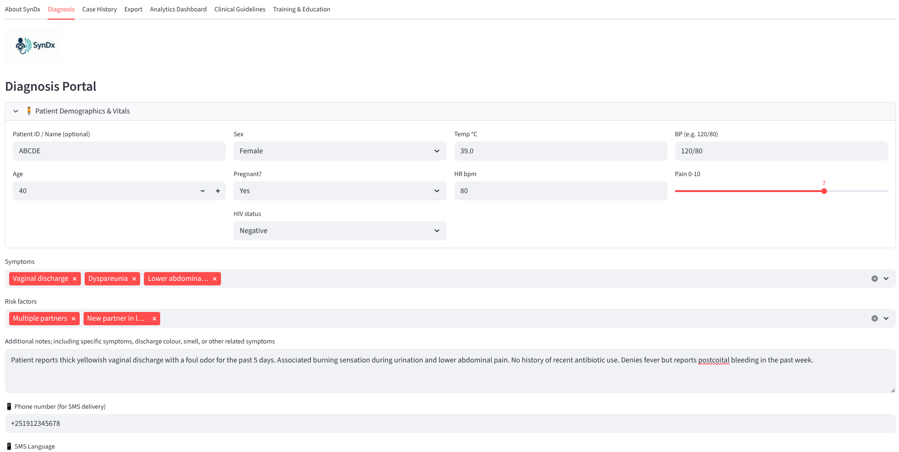

The interactive diagnosis portal of the Syndx dashboard, showing patient demographics, vitals, symptoms, risk factors, and clinical notes input fields. This interface represents one of the core modules within the system architecture, integrating WHO syndromic algorithms and AI-based reasoning outputs for decision support.

**Patient Input Simulation and Rule-Based Diagnosis Mapping**

To evaluate the dashboard, a set of synthetic patient cases was generated. Each case included demographic information such as age, sex, pregnancy, and HIV status; clinical parameters including temperature, blood pressure, heart rate, and pain score; and symptom clusters that directly aligned with WHO guideline definitions, such as vaginal discharge, urethral discharge, genital ulceration, inguinal swelling, or lower abdominal pain. Risk factors such as multiple sexual partners, unprotected sex, recent antibiotic use, or being under 25 years of age were also included, together with short free-text clinical notes. This approach allowed the testing of diverse scenarios that mirror routine presentations in primary healthcare, while maintaining ethical safeguards by avoiding the use of real patient data. The WHO module applied deterministic rules that reflect the guideline(3).

**AI Reasoning Integration**

The AI module was designed not to replace but to complement the WHO algorithm. It generated a parallel diagnostic impression, offering both probable and possible causes of the syndrome, proposed treatment options aligned with WHO standards, and additional interpretive commentary. The AI was explicitly instructed to exclude diagnoses outside the STI domain-for example, respiratory or gastrointestinal infections-and to reinforce WHO regimens as the baseline. When aligned with WHO, the AI outputs served to validate the rule-based result. When broader or more detailed, they provided context, such as highlighting the possibility of co-infections or emphasizing risk factors like pregnancy or HIV status.

**Verification with Synthetic Cases**

The prototype was tested using 25 synthetic cases **(Supplementary Table-1)**, which were entered sequentially into the dashboard. Each case was processed through both the WHO rule-based module and the AI module. Outputs were compared for concordance and discrepancies, with attention to instances where the AI offered broader syndromic categories or diverged from the WHO standard. Mismatches such as pelvic inflammatory disease being classified as vaginal discharge syndrome, or inguinal bubo syndrome being categorized under genital ulcer disease, were carefully documented to highlight potential risks and opportunities for refinement. Safety was assessed by ensuring that no irrelevant AI diagnoses were generated and that all outputs remained within the STI scope.

**Deployment**

Following internal verification and testing in the development environment, the Syndx dashboard was deployed on Streamlit Cloud to provide remote, browser-based access without requiring local installation. Deployment was managed directly from the project’s GitHub repository, with automated builds triggered on each push to the main branch. This ensured that updates to the source code, including modifications to diagnostic logic, interface elements, or integration routines, were reflected in real-time on the live application.

The Streamlit Cloud environment replicated the conda-based configuration used in local development. Key dependencies, including Streamlit, pandas, numpy, scikit-learn, matplotlib, seaborn, plotly, python-dotenv, and the OpenAI Python client, were specified in a requirements.txt file to guarantee consistency and reproducibility across local and deployed instances.

The deployment pipeline incorporated secure handling of API keys and environment variables through Streamlit Cloud’s Secrets Management system. This safeguarded sensitive information, including the OpenAI API key used for AI integration and SMS gateway configurations. Once deployed, the dashboard became accessible via a public URL, enabling use on both desktop and mobile browsers: <https://syndx-dashboard.streamlit.app/>.

**Results**

**System Development and Functionality**

The SynDx prototype was successfully implemented as a browser-based dashboard that integrates WHO syndromic management guidelines with an AI reasoning layer. The interface enabled clinicians to enter structured demographic, clinical, and risk-factor information and to obtain both WHO rule-based outputs and AI-generated interpretations in real time. For each patient case, the system presented syndromic classifications, recommended treatments and triage levels, while also generating a concise AI commentary highlighting agreements, discrepancies, or contextual nuances. The integration of WHO and AI outputs within a single comparison table ensured that users could easily recognize the WHO standard while simultaneously benefiting from AI-supported insights.

SynDx is a lightweight, AI-enhanced digital tool designed to support syndromic management of STIs at the PHC level. The system integrates WHO’s rule-based algorithms with AI-driven reasoning, allowing clinicians to input patient demographics, symptoms, and risk factors to generate both guideline-based and AI-refined diagnoses with interpretive commentary. Key functionalities include case history tracking, export of patient data in CSV format for monitoring and research, an embedded analytics dashboard to visualize diagnostic patterns, direct access to clinical guidelines for quick reference, and a training mode that uses synthetic data for health worker capacity building. By combining real-time diagnosis, surveillance, and education, SynDx functions as both a clinical decision support system and a professional training platform, bridging global standards with AI-enhanced insights **(Figure-2)**.

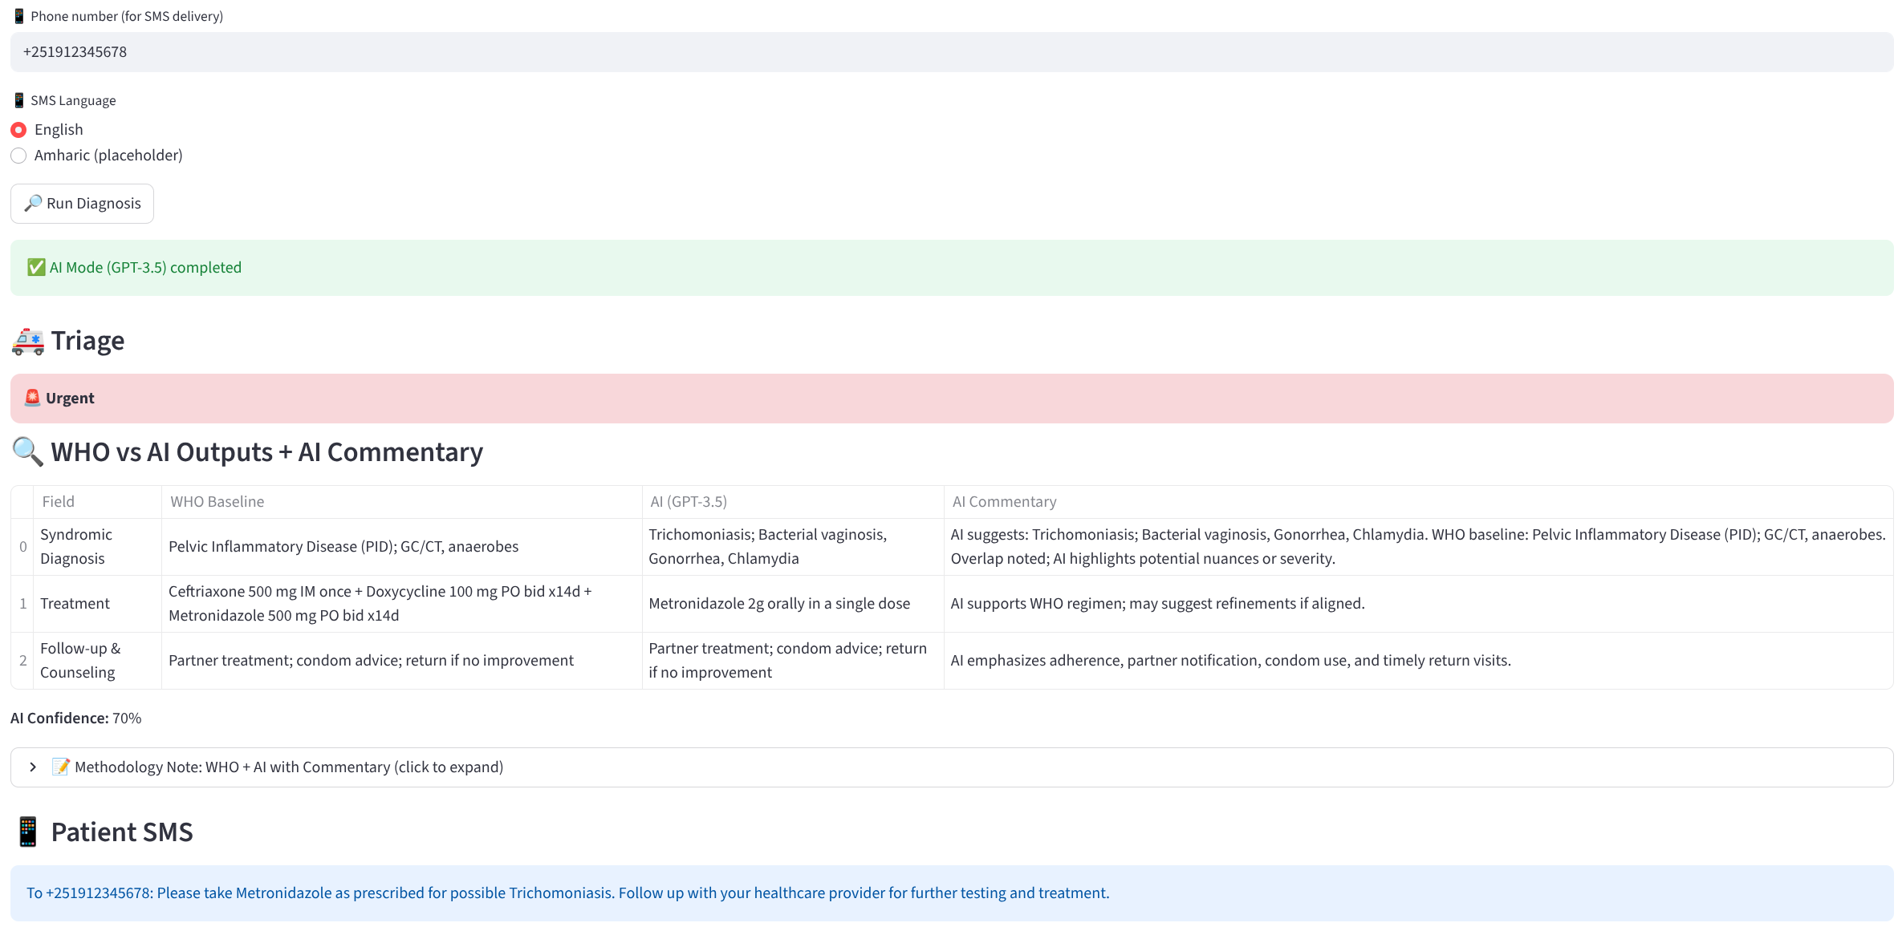

**Figure-2**: Syndx Dashboard-Integrated Triage, WHO vs AI Outputs with Commentary, and Automated SMS Generation

**Validation of Syndromic Agreement**

SynDx was evaluated using 25 synthetic patient cases representing common STI presentations: epididymo-orchitis (n=5), inguinal bubo syndrome (n=6), urethral discharge syndrome (n=7), vaginal discharge syndrome (n=5), pelvic inflammatory disease (n=1), and genital ulcer disease (n=1). The dataset included ten females and fifteen males, aged 16-51 years. HIV status was varied, with ten HIV-negative, eight HIV-positive, and seven unknown cases. Risk factors included recent new partners, multiple concurrent partners, unprotected sex, and exposure to a known partner with an STI. While such behavioral variables are not incorporated in WHO syndromic management, they were processed by the AI module, allowing Syndx to generate individualized reasoning alongside WHO outputs. After refining an initial decision-rule gap, SynDx reproduced all WHO syndromic categories with 100% concordance (Cohen’s Kappa = 1.0). We did not assess concordance between AI outputs and WHO diagnoses, as the AI module was designed to complement rather than replicate WHO guidelines, providing added value through differential diagnoses, triage alerts, and patient communication features **(Supplementary Table-1)**.

Overall, the validation exercise demonstrated that SynDx maintains complete consistency with WHO syndromic classifications while offering additional organism-level insights. This dual capability makes the tool particularly useful in low- and middle-income settings where laboratory confirmation is limited but where more specific treatment recommendations and surveillance data are urgently needed. By anchoring its logic to WHO standards and simultaneously refining outputs with AI reasoning, SynDx emerges as a reliable, interpretable, and practical decision support tool for frontline STI care. The prototype dashboard is publicly accessible at:  
https://syndx-dashboard.streamlit.app/.

**Organism-Specific Refinement**

Although concordance with WHO classifications demonstrated the reliability of the platform, SynDx extended the value of syndromic management by refining each syndrome into organism-specific categories. Urethral discharge syndrome, for example, was consistently attributed to gonorrhea and chlamydia. Genital ulcer disease was further broken down into syphilis, herpes simplex virus, and chancroid. Vaginal discharge syndrome was differentiated into gonorrhea or chlamydia, trichomoniasis, and bacterial vaginosis, while epididymo-orchitis was separated into infections caused by gonorrhea and chlamydia on the one hand, and enteric organisms on the other. These refinements introduced a level of diagnostic granularity that is absent from the WHO syndromic framework but highly relevant to clinical decision-making and antimicrobial stewardship.

**Integration of AI Commentary**

Beyond reproducing WHO categories and adding pathogen-specific clarity, SynDx provided contextual AI commentary that explained the overlap between guideline-based and AI-driven outputs. In cases where WHO and SynDx outputs were identical, the commentary reinforced this agreement and drew attention to additional considerations such as the likelihood of co-infections or the potential severity of the presentation. This approach ensured that WHO guidelines remained the reference point, while the AI component acted as a complementary layer that highlighted nuances, supported clinical reasoning, and guided follow-up decisions.

**User Transparency and Commentary**

A distinctive feature of the dashboard was the commentary layer that compared WHO and AI outputs directly. In cases of agreement, the AI reinforced the reliability of the WHO classification and highlighted factors such as high pain scores or the presence of risk behaviors. In cases of partial mismatch, the AI commentary explicitly noted the overlap and provided rationale, for example clarifying that vaginal discharge syndromes may mask early pelvic inflammatory disease. This interpretive dimension improved the transparency of AI reasoning and demonstrated how such tools could augment clinician awareness rather than act as opaque black boxes.

**Deployment and Accessibility**

Following internal verification and testing in the development environment, the Syndx dashboard was deployed on Streamlit Cloud to provide remote, browser-based access without requiring local installation. Deployment was managed directly from the project’s GitHub repository, with automated builds triggered on each push to the main branch. This ensured that updates to the source code, including modifications to diagnostic logic, interface elements, or integration routines, were reflected in real-time on the live application.

The Streamlit Cloud environment replicated the conda-based configuration used in local development. Key dependencies, including Streamlit, pandas, numpy, scikit-learn, matplotlib, seaborn, plotly, python-dotenv, and the OpenAI Python client, were specified in a requirements.txt file to guarantee consistency and reproducibility across local and deployed instances.

The deployment pipeline incorporated secure handling of API keys and environment variables through Streamlit Cloud’s Secrets Management system. This safeguarded sensitive information, including the OpenAI API key used for AI integration and SMS gateway configurations.

Once deployed, the dashboard became accessible via a public URL, enabling use on both desktop and mobile browsers: <https://syndx-dashboard.streamlit.app/>.

**Discussion**

This study was undertaken to address persistent gaps in the management of STIs in low- and middle-income countries, where WHO syndromic management algorithms remain the standard of care despite their known limitations in sensitivity, specificity, and contextual adaptability. Existing tools developed in countries such as Uganda, Kenya, and India (4,11–13) have primarily focused on WHO algorithms without digitalizing and integrating AI to enhance decision support. Against this backdrop, the Syndx dashboard was developed as a prototype AI-assisted decision support system, designed not to replace WHO guidelines but to harmonize with them-providing additional reasoning, contextualization, and patient communication features. This rationale guided the evaluation of Syndx using synthetic cases to test its fidelity to WHO standards while exploring the added value of AI integration.

The findings from this prototype evaluation highlight the feasibility and potential of SynDx as a next-generation clinical decision support system for syndromic STI management. By demonstrating complete alignment with WHO syndromic guidelines after minor corrections to its internal logic, SynDx has established a strong foundation of validity. At the same time, the tool extends beyond replication of established algorithms by introducing artificial intelligence (AI)-driven refinements that add diagnostic granularity and interpretive support.

The cornerstone of this prototype was its ability to replicate the WHO syndromic approach, which remains the standard in LMICs where diagnostic infrastructure is limited. Our validation with 25 synthetic cases showed that SynDx consistently produced the same syndrome categories as the WHO algorithm, achieving 100% agreement after addressing an initial inconsistency in handling urethral discharge cases. This high level of concordance reassures clinicians and policymakers that the platform can be trusted to maintain compliance with international standards while offering enhanced functionality.

One of the most important contributions of SynDx lies in its ability to refine broad syndromic categories into organism-level detail. For example, while WHO guidelines identify “genital ulcer disease” as a single syndrome, SynDx differentiates among syphilis, herpes simplex virus (HSV), and chancroid as probable causes. Similarly, urethral discharge is further resolved into gonorrhea and chlamydia. These refinements do not replace syndromic management but rather enrich it, offering clinicians a clearer picture of the likely etiologies. This is especially valuable in LMIC settings, where empirical treatments may be broad, costly, and prone to driving antimicrobial resistance (AMR). By narrowing the differential within the syndromic framework, SynDx supports more rational prescribing, aligning directly with global AMR containment priorities.

Beyond classification, SynDx employs AI to provide interpretive commentary, bridging the gap between static algorithms and the complexity of real-world clinical presentations. For each case, AI contextualizes WHO outputs, highlighting overlaps, potential co-infections, or risk-related nuances. For example, in cases with HIV-positive status or pregnancy, SynDx can emphasize urgency, recommend closer follow-up, or flag the need for referral to higher-level care. This interpretive layer offers clinicians more than just a diagnosis; it provides actionable insights grounded in both evidence and patient-specific context. Such a hybrid model-anchoring decisions in WHO rules while layering AI reasoning-ensures that AI functions as an enhancer rather than a replacement, which is critical for clinical adoption and trust.

The utility of SynDx extends beyond individual patient care. By systematically structuring data on symptoms, syndromic categories, probable etiologies, and follow-up recommendations, the tool can generate case-level datasets that feed into national surveillance systems. This dual function has significant potential for Ethiopia and other LMICs, where real-time data on STI trends and treatment outcomes are scarce. For institutions like the Ethiopian Public Health Institute (EPHI), SynDx could serve as both a clinical support tool and a digital surveillance asset, informing strategic planning, resource allocation, and monitoring of AMR patterns. The alignment of clinical decision-making with public health intelligence makes SynDx unique compared to purely clinical reference apps.

We aligned our therapeutic recommendations with internationally recognized guidelines such as the CDC’s *Sexually Transmitted Infections Treatment Guidelines, 2021, available at: (https://www.cdc.gov/sti/hcp/clinical-guidance/index.html?utm_source)*. Previous digital health interventions for STIs, such as reference tools developed in Uganda, Kenya, and India (11–13), primarily serve as repositories of static information. While valuable for reference, they lack real-time diagnostic reasoning, integration with WHO syndromic flowcharts, or structured data capture for surveillance. SynDx addresses these gaps by combining WHO’s standardized algorithms with AI-based interpretive capabilities, offering both a decision-support function and a data-generation platform. This positions SynDx at the intersection of clinical care and digital epidemiology.

As part of the limitations, this prototype was validated using synthetic patient cases rather than real-world clinical encounters. While synthetic data provided a controlled environment for initial testing, field validation is essential to assess usability, diagnostic accuracy in practice, clinician acceptance, and patient outcomes. Second, although the organism-specific refinements provide added value, they remain probabilistic approximations rather than laboratory-confirmed diagnoses. These should therefore be interpreted as guidance for clinical reasoning rather than definitive results. Finally, the app has yet to be integrated with key implementation features such as secure log-in, patient record storage, or SMS-based health education in local languages, which are critical for large-scale deployment.

Future work will involve piloting SynDx in primary healthcare facilities under routine conditions, incorporating clinician feedback, and refining the AI commentary based on local epidemiology. Expanding the platform to include laboratory integration, antimicrobial resistance surveillance, and multi-language patient education will further enhance its value. Additionally, ensuring interoperability with national health information systems and global standards such as HL7 FHIR and OMOP CDM could make SynDx a versatile tool for both clinical care and research.

**Conclusion**

SynDx successfully harmonizes WHO syndromic guidelines with AI reasoning to deliver a reliable, context-sensitive digital decision support tool for STI management. Its ability to replicate WHO outputs while refining them into organism-level differentials addresses a long-standing limitation of syndromic management and offers a pathway for more precise and rational STI care. By coupling clinical decision support with surveillance potential, SynDx represents a promising innovation at the convergence of AI, public health, and digital health.

**Abbreviations**

|  |  |
| --- | --- |
| AMR | Antimicrobial resistance |
| AI | Artificial intelligence |
| EPHI | Ethiopian Public Health Institute |
| GPT | Generative Pre-trained Transformers |
| HSV | Herpes simplex Virus |
| LMICs | low- and middle-income countries |
| NLP | particularly natural language processing |
| STI | Sexually transmitted infection |
| PHC | primary health care |
| WHO | World Health Organization |

**Reference**

1. Bogale EK, Anagaw TF, Tiruneh MG, Fenta ET, Endeshaw D, Delie AM, et al. Prevalence of sexually transmitted infections, and its associated factors among students in Ethiopia: a systematic review and meta-analysis study. BMC Public Health [Internet]. 2024 July 24 [cited 2025 Sept 30];24(1):1976. Available from: https://bmcpublichealth.biomedcentral.com/articles/10.1186/s12889-024-19548-w

2. Gottlieb SL, Spielman E, Abu-Raddad L, Aderoba AK, Bachmann LH, Blondeel K, et al. WHO global research priorities for sexually transmitted infections. The Lancet Global Health [Internet]. 2024 Sept [cited 2025 Sept 30];12(9):e1544–51. Available from: https://linkinghub.elsevier.com/retrieve/pii/S2214109X24002663

3. Guidelines for the Management of Symptomatic Sexually Transmitted Infections. 1st ed. Geneva: World Health Organization; 2021. 1 p.

4. Gupta V, Sharma V. Syndromic management of sexually transmitted infections: A critical appraisal and the road ahead. Natl Med J India [Internet]. 2019 [cited 2025 Sept 30];32(3):147. Available from: https://nmji.in/syndromic-management-of-sexually-transmitted-infections-a-critical-appraisal-and-the-road-ahead/

5. Unemo M, Bradshaw CS, Hocking JS, De Vries HJC, Francis SC, Mabey D, et al. Sexually transmitted infections: challenges ahead. The Lancet Infectious Diseases [Internet]. 2017 Aug [cited 2025 Sept 30];17(8):e235–79. Available from: https://linkinghub.elsevier.com/retrieve/pii/S1473309917303109

6. Otieno FO, Ndivo R, Oswago S, Ondiek J, McLellan-Lemal E, Chen RT, et al. Evaluation of syndromic management of sexually transmitted infections within the Kisumu Incidence Cohort Study. 2015;

7. Fahim YA, Hasani IW, Kabba S, Ragab WM. Artificial intelligence in healthcare and medicine: clinical applications, therapeutic advances, and future perspectives. Eur J Med Res [Internet]. 2025 Sept 23 [cited 2025 Sept 30];30(1):848. Available from: https://eurjmedres.biomedcentral.com/articles/10.1186/s40001-025-03196-w

8. Bajwa J, Munir U, Nori A, Williams B. Artificial intelligence in healthcare: transforming the practice of medicine. Future Healthcare Journal [Internet]. 2021 July [cited 2025 Sept 30];8(2):e188–94. Available from: https://linkinghub.elsevier.com/retrieve/pii/S2514664524005277

9. Rong G, Mendez A, Bou Assi E, Zhao B, Sawan M. Artificial Intelligence in Healthcare: Review and Prediction Case Studies. Engineering [Internet]. 2020 Mar [cited 2025 Sept 30];6(3):291–301. Available from: https://linkinghub.elsevier.com/retrieve/pii/S2095809919301535

10. Noorbakhsh-Sabet N, Zand R, Zhang Y, Abedi V. Artificial Intelligence Transforms the Future of Health Care. The American Journal of Medicine [Internet]. 2019 July [cited 2025 Sept 30];132(7):795–801. Available from: https://linkinghub.elsevier.com/retrieve/pii/S0002934319301202

11. Siyamayambo C, Phalane E, Phaswana-Mafuya RN. Diagnosis and Management of Sexually Transmitted Infections Using Artificial Intelligence Applications Among Key and General Populations in Sub-Saharan Africa: A Systematic Review and Meta-Analysis. Algorithms [Internet]. 2025 Mar 7 [cited 2025 Oct 6];18(3):151. Available from: https://www.mdpi.com/1999-4893/18/3/151

12. Omosa-Manyonyi GS, De Kam M, Tostmann A, Masido MA, Nyagah N, Obimbo MM, et al. Evaluation and optimization of the syndromic management of female genital tract infections in Nairobi, Kenya. BMC Infect Dis [Internet]. 2023 Aug 22 [cited 2025 Oct 6];23(1):547. Available from: https://bmcinfectdis.biomedcentral.com/articles/10.1186/s12879-023-08442-2

13. Wi TE, Ndowa FJ, Ferreyra C, Kelly‐Cirino C, Taylor MM, Toskin I, et al. Diagnosing sexually transmitted infections in resource‐constrained settings: challenges and ways forward. J Intern AIDS Soc [Internet]. 2019 Aug [cited 2025 Sept 30];22(S6):e25343. Available from: https://onlinelibrary.wiley.com/doi/10.1002/jia2.25343